Tribhuwan University
Institute of Science and Technology
Bhairahawa Multiple Campus

A Project Proposal
On
Sajilo Sahayata (Disaster Reporting & Coordination System)
(In partial fulfilment of the requirement of Bachelor of Science in Computer Science & Information Technology (BSc. CSIT))

Submitted By:
Arun Neupane (30282 / 078)
Bijay Kumar Chaudhary (30287 / 078)
Sunil Paudyal (30335 / 078)

Submitted To:
Department of Computer Science and Information Technology
Bhairahawa Multiple Campus
Bhairahawa, Nepal
May, 2025


Certificate of Approval

This is to certify that the project proposal titled “Sajilo Sahayata” prepared by Arun Neupane (30282/078), Bijay Kumar Chaudhary (30287/078) and Sunil Paudyal (30335/078) in a partial fulfilment of the project of seventh semester of BSc. Computer Science and Information Technology has been well studied and approved for further development.

…………………………………
Sunil Kumar Shah
Co-ordinator
Department of Computer Science and Information Technology
Bhairahawa Multiple Campus,
Bhairahawa, Nepal

Table of Content
Certificate of Approval i
List of Figure iii
1. Introduction 1
2. Problem Statement 2
3. Objectives 4
3.1. Main Objective: 4
3.2. Specific Objectives: 4
4. Methodology 5
4.1. Requirement Identification 6
4.1.1. Literature Review 6
4.1.2. Requirement Analysis 6
4.2. Feasibility Study 8
4.2.1. Technical Feasibility Study 8
4.2.2. Economic Feasibility Study 9
4.2.3. Operational Feasibility Study 9
4.2.4. Schedule Feasibility Study 9
4.3. High Level Design of System 10
4.3.1. Flowchart 10
4.3.2. Use Case Diagram 11
4.3.3. Activity Diagram 12
5. Tools to be used 13
6. Expected Outcomes 14
References 15

List of Figure
Figure 4: Agile Development Model 5
Figure 4.2.4: Gantt Chart for Sajilo Sahayata 9
Figure 4.3.1: Flowchart for Sajilo Sahayata 10
Figure 4.3.2: Use Case Diagram for Sajilo Sahayata 11
Figure 4.3.3: Activity Diagram for Sajilo Sahayata 12

Introduction
Nepal is highly vulnerable to various natural disasters, including earthquakes, floods, and landslides, which frequently cause significant loss of life and property. Effective disaster management requires timely and accurate information flow between citizens and government authorities. Current systems often suffer from delays, lack of coordination, and unreliable information. Furthermore, citizens also face challenges in reporting and addressing everyday community issues. Sajilo Sahayata is proposed as a solution to bridge these gaps. It is a web and mobile-based platform designed to: Enable citizens to report emergencies and community issues in real-time. Provide government authorities with a centralized dashboard for efficient incident management. Improve the speed and accuracy of disaster response and public service delivery. This platform aims to leverage technology to foster a more resilient and responsive community.

2. Problem Statement
Nepal, due to its complex geography, fragile infrastructure, and limited digital penetration in rural areas, faces critical challenges in disaster management and public service coordination. The current systems for disaster reporting and community issue resolution are fragmented and inefficient, relying heavily on traditional methods such as physical visits, phone calls, or separate, siloed applications. These methods often result in delays, loss of information, and uncoordinated responses during emergencies.
There is an urgent need for a centralized, real-time, and citizen-inclusive digital platform that allows timely reporting, accurate verification, and streamlined coordination among government bodies. The lack of such a system not only hampers effective emergency response but also undermines public trust and participation in local governance. Sajilo Sahayata aims to address these issues by creating an integrated digital ecosystem for disaster management and civic coordination in Nepal.
Key Problems in the Context of Nepal.
- Fragmented and Redundant Communication Channels
  - Citizens report issues via multiple disconnected means: ward offices, police stations, NGOs, and helplines.
  - These parallel systems cause delays and lead to poor tracking of complaints.
- Absence of Real-Time Information Flow
  - Many rural and urban areas lack platforms for immediate, real-time updates during floods, landslides, fires, or road blockages.
  - Emergency teams often operate with outdated or second-hand information.
- Verification and Authenticity Issues
  - In crisis scenarios, it's difficult to verify the legitimacy of user-reported incidents.
  - This causes confusion, resource misallocation, and spread of misinformation (especially via social media).

- Low Digital Civic Participation
  - A significant portion of the population remains passive due to lack of awareness or accessible tools for engagement.
  - Existing apps/platforms rarely allow public tracking of issue status or offer feedback mechanisms.
- Weak Inter-Agency Coordination
  - Agencies duplicate efforts or overlook key areas due to poor synchronization.
  - Lack of interoperability between municipal systems, disaster response units, and local law enforcement.

3. Objectives

3.1. Main Objective:
- To design and develop an integrated, real-time disaster management and civic coordination system tailored for Nepal’s socio-geographic context.
- To bridge the gap between citizens and authorities by enabling efficient, transparent, and timely communication during emergencies and community-level issues.
- To comprise web, incorporating modern geospatial and communication technologies to ensure reliability, scalability, and inclusiveness.

3.2. Specific Objectives:
- Develop a user-centric reporting interface:
  - Allow real-time submission of incident reports with GPS coordinates
  - Support multimedia attachments (images, videos) for context-rich reporting.
  - Enable easy categorization of incidents by type (natural disasters, infrastructure issues, etc.).
  - Implement OTP-based user authentication to minimize spam and enhance accountability.
- Create a dynamic incident management dashboard for government agencies:
  - Visualize reports on a real-time interactive map using geospatial technologies.
  - Prioritize and assign tasks to appropriate response teams with tracking capabilities.
- Enhance citizen engagement and trust:
  - Provide transparent issue tracking with status updates for reported incidents.
  - Encourage community participation through feedback loops and response ratings.
  - Support multiple languages (including Nepali) for inclusiveness across regions.

4. Methodology
The software development model chosen for the Sajilo Sahayata is the Agile Development Model. Agile is selected due to its flexibility in accommodating changing requirements, which is crucial in a disaster management system aimed at local government. The iterative and incremental nature of Agile allows for continuous updates and testing, ensuring timely delivery of essential features while maintaining system reliability. Additionally, Agile promotes regular communication with stakeholders, enabling effective alignment with local government protocols and integrating real-time feedback effectively.

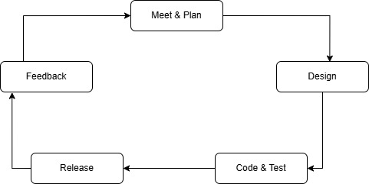

Figure 4: Agile Development Model

4.1. Requirement Identification
Requirement identification involves understanding the needs and expectations of stakeholders, analysing existing systems, and defining the features and functionalities of the proposed system.

4.1.1. Literature Review
Nepal has taken several steps toward improving disaster risk reduction and digital governance. However, a fully integrated, real-time, citizen-centric disaster coordination system is still lacking. Below are the key systems.
- BIPAD Portal (Building Information Platform Against Disaster)
Led by the Government of Nepal under the Ministry of Home Affairs, BIPAD is a national platform aimed at disaster risk reduction, data integration, and visualization. While it supports data-driven decision-making, it primarily focuses on institutional-level data and lacks robust citizen reporting capabilities. [1]
- Nepal Disaster Risk Reduction (DRR) Portal
This portal consolidates national disaster statistics and risk mapping but does not support interactive user engagement or real-time reporting from the public. [2]
- Ushahidi Platform
A global open-source crowdsourcing tool used for crisis mapping and data visualization. Although not Nepal-specific, it has been adapted during crises in various countries. Ushahidi shows the value of public-sourced data but lacks direct integration with government response frameworks in Nepal. [3]

4.1.2. Requirement Analysis
The requirements analysis is broken down into two sections namely function requirements and non-functional requirements and they are discussed below.

4.1.2.1. Functional Requirement Analysis

4.1.2.1.1. For Citizens
- User Registration and Authentication:
  - Register using a mobile number or email address.
  - Secure OTP-based login for identity verification.
  - Edit and manage user profile (name, contact info, location).
- Incident Reporting:
  - Submit incidents with:
    - Text descriptions.
    - GPS-based location tagging.
    - Photo and video uploads.
    - Categorization (e.g., earthquake, flood, fire, road blockage, health emergency).
  - View history and status of submitted reports.
  - Receive real-time notifications, alerts, and updates on reported issues.
- Map Interaction:
  - View live incident map with markers and status indicators.
  - Filter incidents based on category, severity, or location.
  - Zoom in/out for locality-specific or nationwide visualization.

4.1.2.1.2. For Government Officials
- Authentication and Access:
  - Role-based login system (local official, provincial admin, federal responder, etc.).
  - Manage permissions and roles for different government users.
- Incident Management:
  - Access real-time dashboard of reported incidents.
  - Verify incoming reports using supporting evidence and GPS data.
  - Track and update progress of each incident (pending, under review, resolved).
- Communication:
- Send broadcast alerts or incident-specific messages to affected citizens.

4.1.2.2. Non-Functional Requirement Analysis
- Performance:
  - All system interactions (page loads, form submissions, map renders) should respond fast under normal load.
  - System should support thousands of concurrent users, especially during disaster peaks.

- Security:
  - OTP-based secure authentication for users and officials.
  - End-to-end encryption of sensitive data (e.g., user data, location, media).
  - Protection against web threats: SQL injection, XSS, CSRF, DoS attacks.
  - Periodic security audits and role-based access controls.
- Usability:
  - Clean, intuitive interface with simplified navigation.
  - Full responsiveness across devices (desktop, tablet, mobile).
  - Multi-language support (initially Nepali and English) for wider accessibility.
  - Offline capabilities for users in low-connectivity areas (data synced when online).
- Reliability:
  - 99.9% uptime with redundant servers and fallback systems.
  - Real-time data syncing and conflict resolution mechanisms.
  - Regular system health checks and failure recovery procedures.
- Scalability:
  - Modular architecture to add new features or integrate with external systems.
  - Cloud-native deployment for auto-scaling based on demand.
  - Designed to support a nationwide rollout across municipalities and provinces.

4.2. Feasibility Study

4.2.1. Technical Feasibility Study
- The technologies chosen ReactJs for the frontend, Node.js for the backend, Firebase for real-time data handling, and open street maps for geospatial visualization—are mature, widely supported, and proven effective for real-time applications.
- Open-source libraries and frameworks reduce licensing and long-term maintenance costs.
- The development team is already proficient in the selected technologies, reducing the learning curve and accelerating implementation.
- The platform is deployable on common cloud environments like Firebase Hosting, Vercel, Render ensuring high availability with minimal infrastructure overhead.

4.2.2. Economic Feasibility Study
- Estimated operational cost: NPR 1,500–3,000/month (covers hosting, database usage under moderate scale, and domain/email services) and almost no or minimal expense for production as we have been using open source and free libraries.
- The system will reduce the cost of delayed disaster response, improve coordination, and minimize losses, making it economically viable.
- Long-term potential for government adoption or external funding through NGOs, disaster response donors, or innovation grants.

4.2.3. Operational Feasibility Study
- The system is accessible through modern web browsers and can be extended into a mobile PWA or native app if needed.
- Designed for intuitive use by both citizens (reporters) and officials (responders).
- Short training workshops or user manuals can be provided for local government bodies and volunteers.
- Real-time updates, notification systems, and automated maps improve operational responsiveness during emergencies.

4.2.4. Schedule Feasibility Study

Sajilo Sahayata
Dates  Work | April 15 | May 13 | May 23 | June 1 | June 20 | June 25
Planning
Design
Coding
Test & Debug
Implementation
Documentation

Figure 4.2.4: Gantt Chart of Sajilo Sahayata

4.3. High Level Design of System

4.3.1. Flowchart

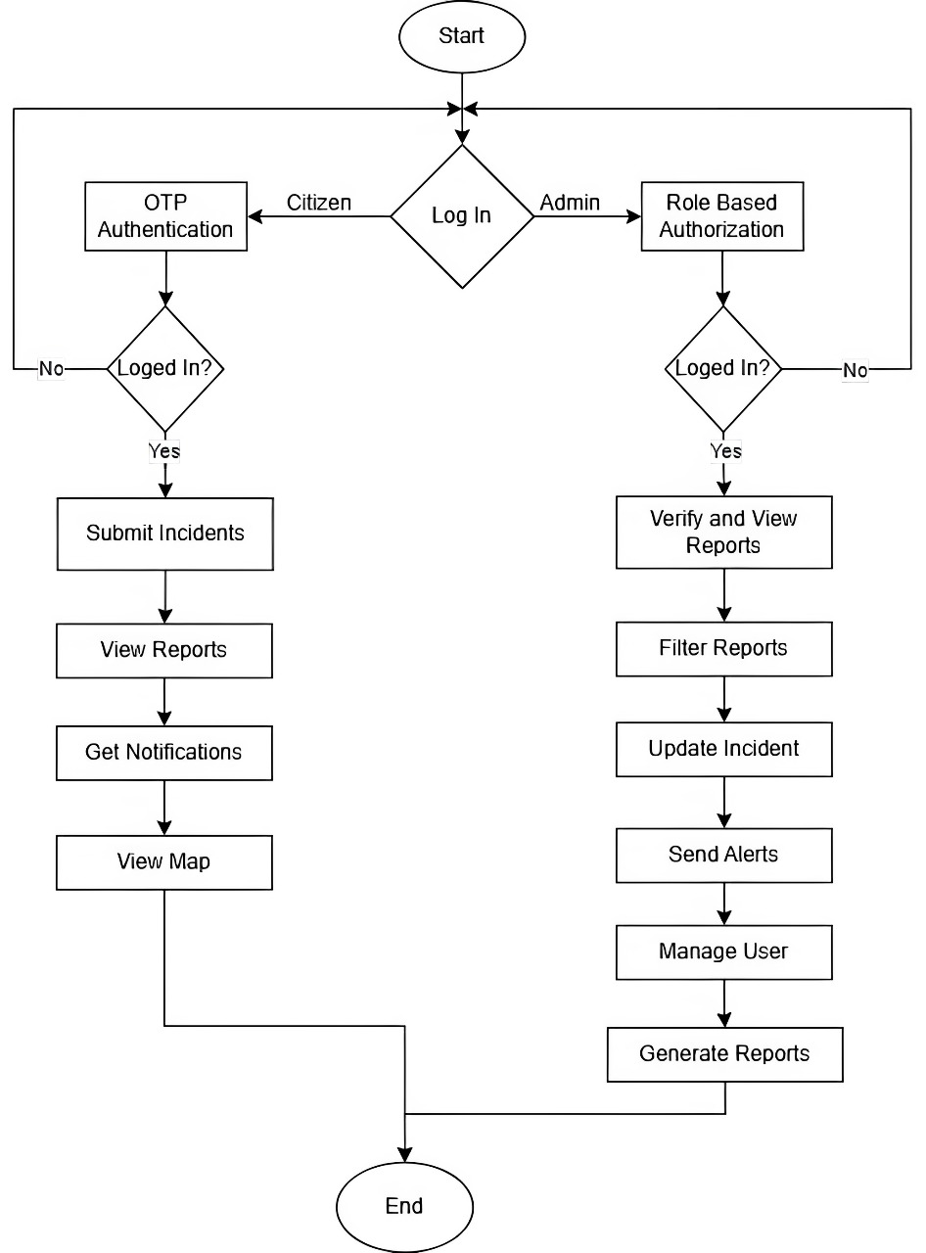

Figure 4.3.1: Flowchart of Sajilo Sahayata

4.3.2. Use Case Diagram

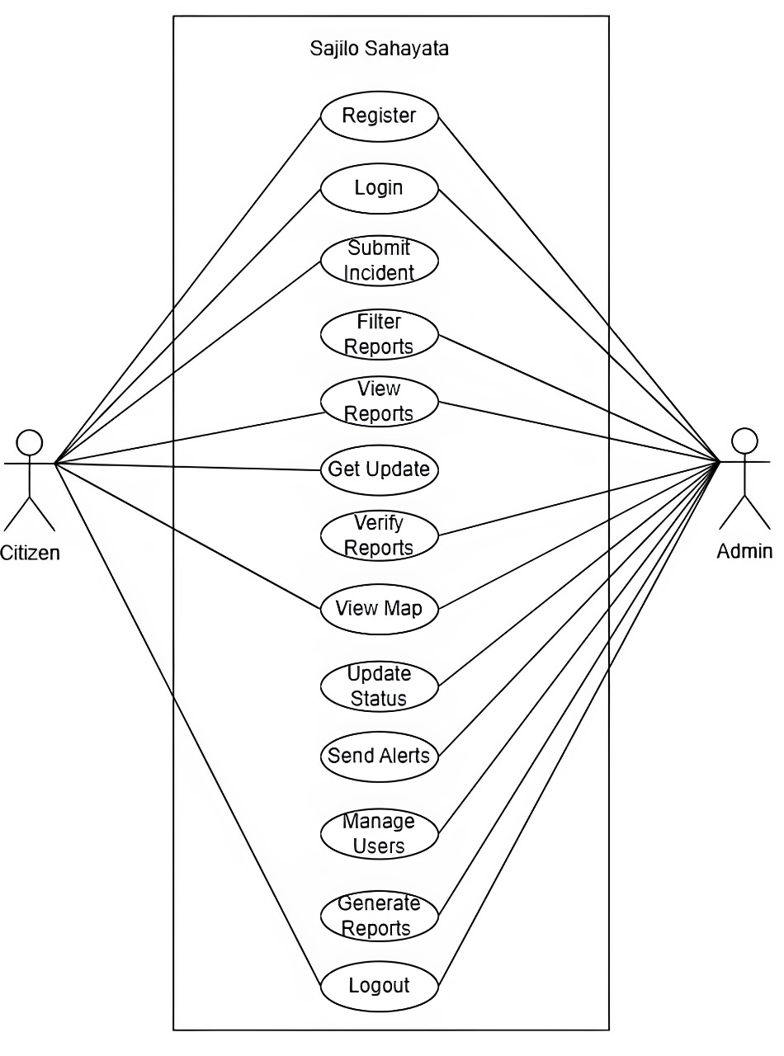
Figure 1.3.2: Use Case Diagram of Sajilo Sahayata

4.3.3. Activity Diagram

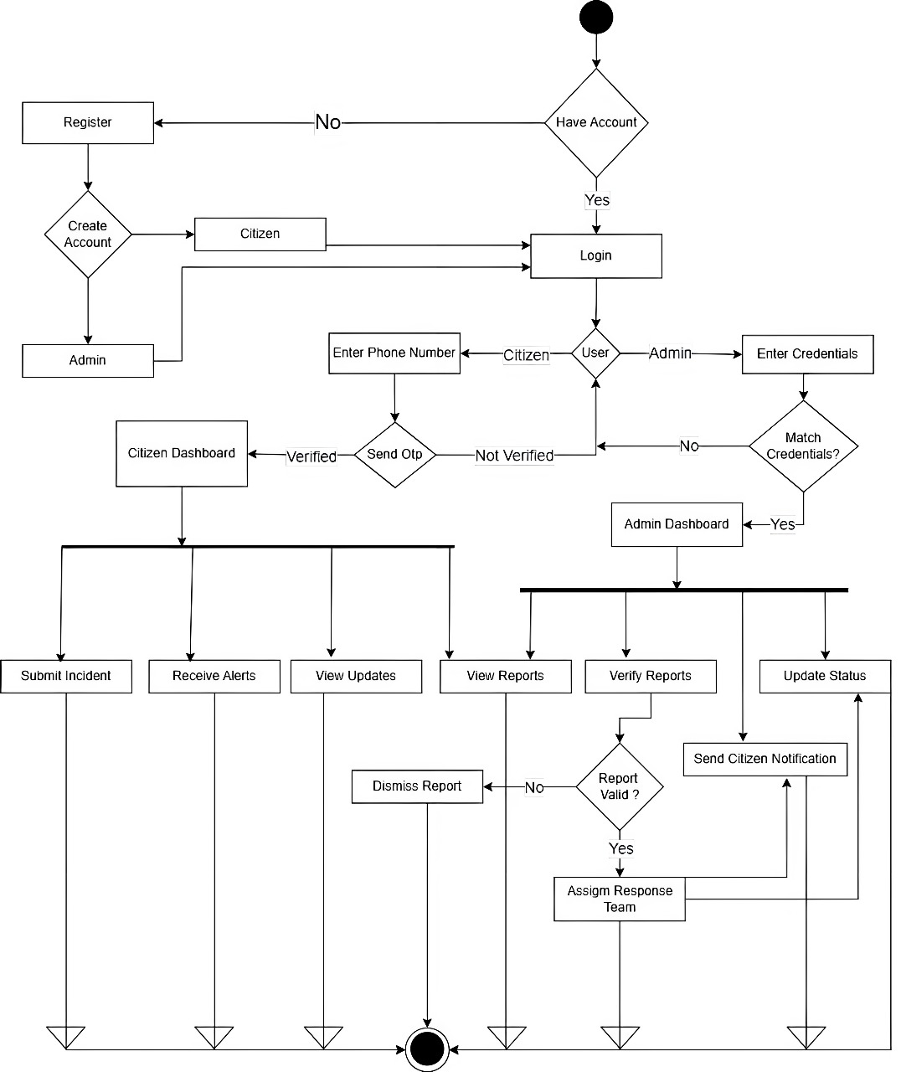

Figure 4.3.3: Activity Diagram of Sajilo Sahayata

5. Tools to be used
- Software used
- Frontend: React Js, Tailwind CSS
- Backend: Node Js, Express Js
- Authentication: Firebase
- Database: Postgresql

- Hardware Used
- Processor: Intel i5
- Clock speed: 2.5GHz
- RAM: Minimum 4GB
- SSD: Minimum 256GB

6. Expected Outcomes
The implementation of the Sajilo Sahayata system is anticipated to bring transformative improvements in disaster response, local issue management, and citizen-government engagement.
- Improved Efficiency Faster Incident Reporting:
Citizens will be able to report incidents within 1–2 minutes, reducing the reporting time compared to traditional methods. Real-time data transmission and automated alerting will reduce response initiation time. Centralized dashboards for officials will simplify the management of incoming reports, prioritization, and resource deployment.
- Enhanced Accuracy Location Precision:
Integration of GPS will ensure incidents are accurately mapped reducing location ambiguity. Photos and videos attached to reports will increase verification accuracy and context clarity.
- Increased Citizen Engagement User-Friendly Interface:
A mobile-responsive platform will make it accessible to a wide user base, including remote communities. Citizens will receive status updates and notifications, boosting transparency and trust. Gamification or acknowledgment features (e.g., badges, report counts) may further encourage active reporting.
- Long-Term Impact Resilient Communities:
Faster, transparent responses will empower communities and mitigate disaster impact. E-Governance Enablement: The system will serve as a foundational module for broader e-governance strategies in Nepal. Sustainable Development: By addressing civic issues proactively, the platform will contribute to sustainable urban and rural development.

References
[1] BIPAD Portal. (n.d.). Building Information Platform Against Disaster. Government of Nepal. Retrieved from: [Online]. Available: https://bipadportal.gov.np [Accessed 13 May 2025]
[2] Nepal Disaster Risk Reduction, DRR Platform. Retrieved from: [Online]. Available: https://www.drr.com/ [Accessed 13 May 2025]
[3] Ushahidi. (n.d.). Ushahidi Platform. Retrieved from: [Online]. Available: https://www.ushahidi.com [Accessed 13 May 2025]

